Module Integrating and Testing Report
In this stage, all the previous components-core model classes, controllers, GUI interfaces and the database are brought together into one complete, functional application. The purpose of this report is to document the integration process, the bugs that were fixed and the results of the system-wide tests.
The banking system was built using a Model-View-Controller architecture combined with a DAO persistence layer.
Boundary layer
Loginform
RegisterCustomerForm
CustomerDashboard
OpenAccountForm
Handles user interaction with no business logic.
Controller layer
AuthController
AccountController
TransactionController
Validates inputs, manages workflow and delegation business logic to the model.
Core model layer
Customer (abstract), IndividualCustomer, BusinessCustomer
Account (abstract), SavingsAccount, InvestmentAccount, ChequeAccount
Interfaces (Withdrawable,InterestBearing)
Implements the business behaviour of the system
Data Access Layer
CustomerDAO
AccountDAO
TransactionDAO
Manages all database operations using SQLite+ JDBC.
Database Layer (SQLite)
Persistent storage for customers, accounts and transaction history.

Integration Steps Completed
Successful authentication now passes a fully initialized Customer object to CustomerDashboard.
A critical integration fix was:
customer.setUsername(username);
This ensures all database queries for account loading use the correct customer identifier.
Integrating account creation with the database
The previously failing account creation process was fully corrected.
Now, AccountController → AccountDAO → SQLite works seamlessly.
This was achieved by fixing:
- Username mapping
- getCustomerId() logic
- SQL INSERT statements
Transaction flow integration
Deposit and withdrawal requests now:
- Update the Account object
- Persist the change in SQLite
- Log the action in the transactions table
- Refresh the GUI to show new balances
All components now stay in sync.
Loading accounts upon login
When a customer logs in, AccountDAO.loadAccountsForCustomer() retrieves all customer accounts from the database and populates the dashboard.
This confirms that:
GUI → Controller → DAO → Database → Model → GUI
is now fully integrated.

Integration testing
A set of end-to-end tests were performed to confirm that the system behaves correctly when all components work together.
Linking login to dashboard
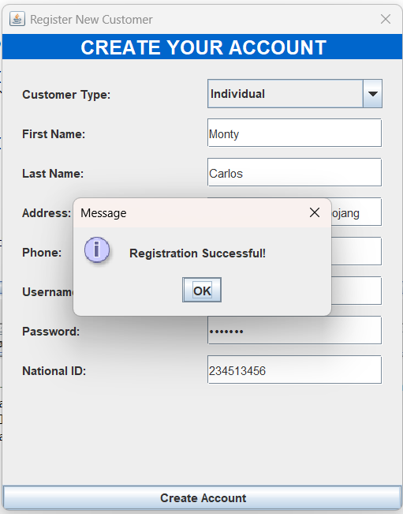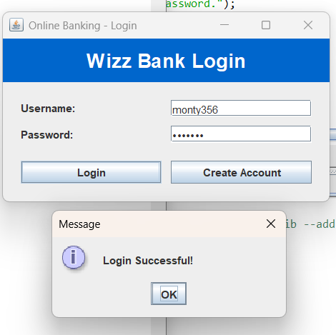
Account creation
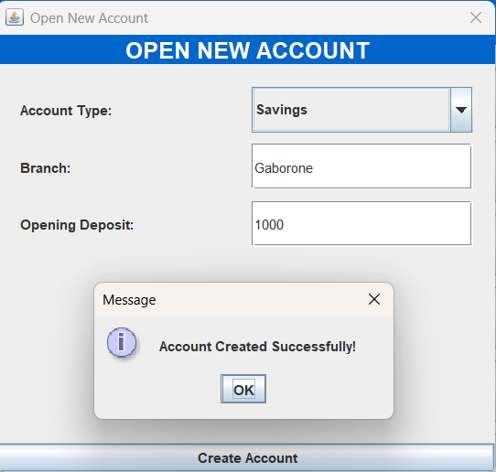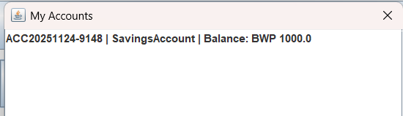

Deposit and withdrawal
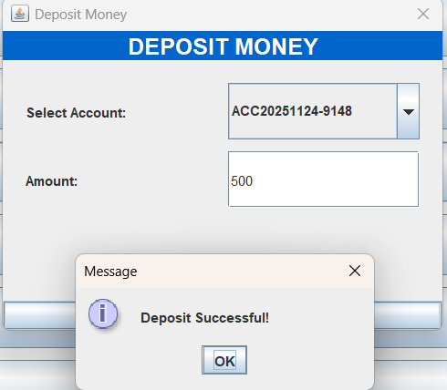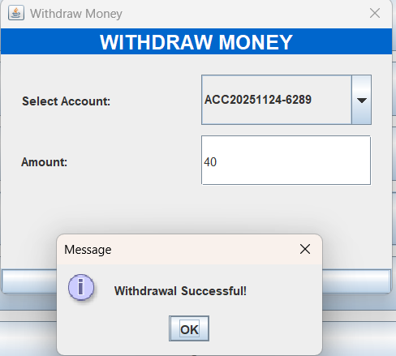

Summary
Component | Status | Notes
Login flow | Working | Username persistence fixed
Account creation | Working | Database ID mapping corrected
Deposit and withdrawal | Working | Fully synced with database
Interest logic | Working | Logged correctly
Dashboard loading | Working | Accounts load dynamically
Database persistence | Working | No resets or data loss
Conclusion
The banking system is fully integrated and operational. All layers from the GUI to the database communicate correctly, ensuring persistent and reliable behaviour.

